WLF7 Landslide Science and Practice for Safe and Resilient Communities

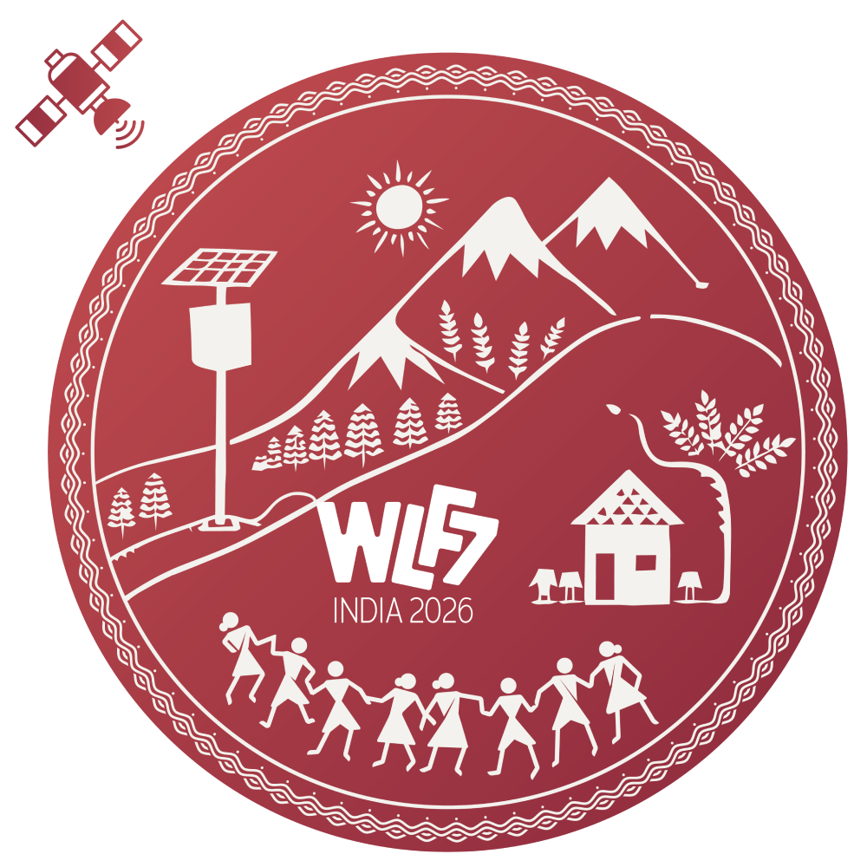 | Extended Abstract Template  7th World Landslide Forum (WLF7)  Faridabad, India | 23–27 November 2026

Title of Contribution (Maximum 100 characters, including spaces)
<Insert>

Firstname Lastname¹, Secondname Lastname², Thirdname Lastname¹

¹ Affiliation, Institution, City, Country

² Affiliation, Institution, City, Country

Corresponding author email: <Insert>

Abstract

(500 – 1000 words)

[Text begins here. The abstract should be self-contained and clearly describe the purpose of the study, the methods or approach adopted, the key results or outcomes, and the main conclusions and implications for landslide science, risk reduction, or practice. The text should be written in clear scientific English and be suitable for oral or e-poster presentation at the World Landslide Forum.]

Keywords:

<Keyword 1; Keyword 2; Keyword 3; Keyword 4; Keyword 5 (3–7 keywords)>

Formatting notes

- Font: Times New Roman, 12 pt
- Alignment: Justified

